HELIPORT
INSPECTION REPORT
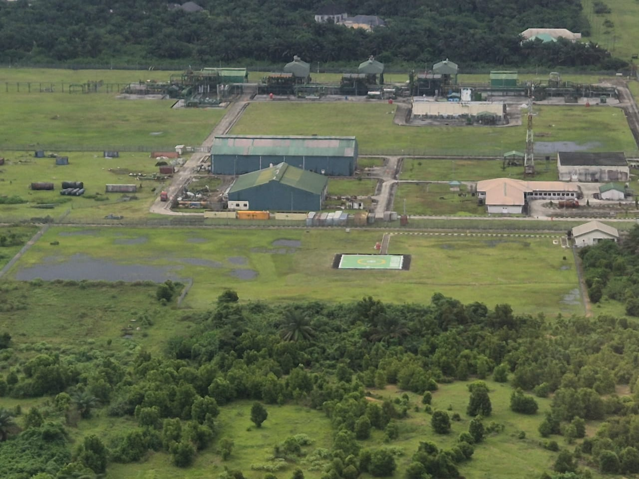

Installation Name | NORTH BANK
Owner/Operator | RENAISSANCE
Inspector | OLISA KENECHUKWU
Operational Clearance  (Day/Night) | DAY ONLY
D Value & T Value | 12.6T, 21M
Date of Previous Inspection | 27TH SEPT 2024
Date of Current Inspection | 1ST SEPT 2026
Date of Next Inspection  (Maximum 2 years – Manned locations)  (Maximum 2 years – NUI locations) | 31ST AUG 2028
NCAA certificate validity

LANDING SITE INSPECTION – REPORT

This checklist is designed to be used by a trained helideck inspector to record his results while conducting an inspection and making notes. The checklist is used for referencing when completing the inspection report, which consists of the Inspector’s Executive Summary, Non Conformity Listing, HLL listing and endorsement page.

The inspection report should be completed as soon as possible but within one weeks of the actual inspection and submitted to the Base Chief Pilot. Prior to the ‘Helideck Operating Certificate’ being issued the Chief Pilot and inspector should consult with the training department and complete the HLL listing with limitation, if there are any. If no limitations are imposed on the landing site the HLL listing should be annotated ‘No limitations imposed on this landing site’.

The inspection report should then be endorse and publish on the WASBU HUMP Operations network. The Head of Flight Operations and Quality & Safety Operations should also be included on this distribution list.

The completed inspection checklist in hard copy will be archived on the base for a period of 4 years and a digital copy also placed on the company ‘WASBU HUMP Operations’ network drive. The current copy of the inspection report will also be kept in hard copy in a designated folder marked ‘Landing Site Inspection Reports’ in the Helideck Inspectors Office.

All items of the inspection should be viewed and details annotated on the checklist. If an item is not applicable then it should be annotated as such.

During the two-year period between full landing site inspections the HLL must be updated to include all restrictions imposed on the landing site. The operation’s room landing site white board should be updated with current restrictions imposed and the Landing Site Status Report updated within 7 days off the completion of the inspection.
Non-conformances are classified as:
- High Priority Critical Actions (these actions must be addressed before air operations can commence)
- Medium Priority Actions (these actions may impact continued operations and restrictions may be imposed)
- Low Priority Actions (these actions may lead to operating restrictions and must be addressed before a full approval is given)

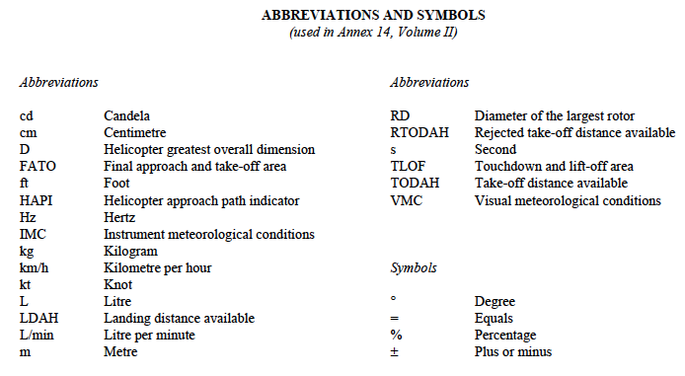

Definitions

Accuracy. A degree of conformance between the estimated or measured value and the true value.

Datum. Any quantity or set of quantities that may serve as a reference or basis for the calculation of other quantities

Declared distances — heliports.
- Take-off distance available (TODAH). The length of the FATO plus the length of helicopter clearway (if provided) declared available and suitable for helicopters to complete the takeoff.
b) Rejected takeoff distance available (RTODAH). The length of the FATO declared available and suitable for
helicopters operated in performance class 1 to complete a rejected takeoff
c) Landing distance available (LDAH). The length of the FATO plus any additional area declared available and
suitable for helicopters to complete the landing maneuver from a defined height.

Dynamic load-bearing surface. A surface capable of supporting the loads generated by a helicopter conducting an emergency
touchdown on it.

Elevated heliport. A heliport located on a raised structure on land.

Ellipsoid height (Geodetic height). The height related to the reference ellipsoid, measured along the ellipsoidal outer normal
through the point in question.

Final approach and takeoff area (FATO). A defined area over which the final phase of the approach maneuver to hover or
landing is completed and from which the takeoff man oeuvre is commenced. Where the FATO is to be used by helicopters
operated in performance class 1, the defined area includes the rejected takeoff area available.

Helicopter air taxiway. : A defined path on the surface established for the air taxiing of helicopters.

Helicopter clearway: A defined area on the ground or water, selected and/or prepared as a suitable area over which a helicopter
operated in performance class 1 may accelerate and achieve a specific height.

Helicopter ground taxiway: A ground taxiway intended for the ground movement of wheeled undercarriage helicopters.
Helicopter stand. An aircraft stand which provides for parking a helicopter and where ground taxi operations are completed or
where the helicopter touches down and lifts off for air taxi operations.

Heliport: A defined helicopter landing site located on an offshore premises used for the exploitation of oil or gas.

Obstacle: All fixed (whether temporary or permanent) and mobile objects, or parts thereof, that:
a) are located on an area intended for the surface movement of aircraft; or
b) extend above a defined surface intended to protect aircraft in flight; or
c) stand outside those defined surfaces and that have been assessed as being a hazard to air navigation.

Protection area: An area within a taxi-route and around a helicopter stand, which provides separation from objects, the FATO,
other taxi-routes and helicopter stands, for safe maneuvering of helicopters.

Rejected takeoff area: A defined area on a heliport suitable for helicopters operating in performance class 1 to complete a
rejected takeoff.

Safety area: A defined area on a heliport surrounding the FATO that is free of obstacles, other than those required for air
navigation purposes and intended to reduce the risk of damage to helicopters accidentally diverging from the FATO.

Shipboard heliport. A heliport located on a ship that may be purpose or non-purpose-built. A purpose-built shipboard heliport
is one designed specifically for helicopter operations. A non-purpose-built shipboard heliport is one that utilizes an area of
the ship that is capable of supporting a helicopter but not designed specifically for that task.

Static load-bearing surface: A surface capable of supporting the mass of a helicopter situated upon it.

Surface-level heliport: A heliport located on the ground or on the water.

Taxi-route: A defined path established for the movement of helicopters from one part of a heliport to another. A taxi-route
includes a helicopter air or ground taxiway that is centered on the taxi-route.

Touchdown and lift-off area (TLOF): An area on which a helicopter may touch down or lift off.

Winching area: An area provided for the transfer by helicopter of personnel or stores to or from a ship.

INSTALLATION DETAILS
Item | Comments
Installation Name | NORTH BANK
Installation Type  Surface Level Heliport:  - Runway type FATO  - Single Pad FATO  - Multi Pad FATO  - Elevated Heliport | SINGLE PAD FATO
Location of Inspection | NORTH BANK CPF
Area of operations | FORCADOS
Owners Address | RENAISSANCE NIGERIA BURUTU LGA DELTA STATE
Name of contact on vessel
Job Position | EFE IGWE FACILITY MAMAGER / PRODUCTION UNIT MANAGER
Phone
E-mail
Installation Manager | 08122200417
FATO & TLOF drawings – (a list of details which should be included at the end of this section)  Drawing number:  Date:  Do the plans accurately show the detail that is required? If no, state omissions. | COMPLIANT
Heliport Elevation  AMSL (feet) | 5M
Installation identification  Location of name  Location of “H” or Aiming Point  Clearly visible  Illumination | COMPLIANT

ONSHORE HELIPORT INSPECTION CHECKLIST
Manuals  Annex 14 Vol. II Aerodromes  Helicopter Procedures Manual detailing:  - Normal duties  - Emergency response  - Training  - Refuelling  - Dangerous Goods  ICAO/IATA DG Regulations  Passenger Safety Briefing for aircraft type being used  - Controlled Copy?  - In Date?  - Readily Available?  Does Operators SOPs include aviation emergency procedures guidance for HLO, OIM/Captain and Radio Operator? | COMPLIANT  NON COMPLIANT - EXPIRED  COMPLIANT

Touch Down & Lift Off Area (TLOF) -Ref icao annex 14 vol II
Item | Comment
Number of TLOFs:  - Shape of TLOF on site (Maybe any shape) :  - Dimensions of TLOF on site:  (must be at least .83D of the helicopter intended for landing) | COMPLIANT
Location of TLOFs:  - One TLOF shall be located within the FATO or one or more TLOFs shall be collocated with helicopter stands.  - If located within the FATO it must be within .5D from the edge of the FATO.  - Elevated Heliports must Have one TLOF Coincidental with the FATO | COMPLIANT
Slope of TLOF:  (Sufficient to prevent water accumulation, but not be more than 2° in any direction,) | COMPLIANT
TLOF Load Bearing in metre tons:  - TLOF located within the FATO – must have dynamic loading capable for helicopter  - TLOF collocated with Helicopter Stand – must be static bearing capable for helicopter  - Check test data documents.  Maximum Load Markings  - Located within the boundary of the TLOF or FATO: Yes or No  - Readable on final approach: Yes or No  - White numbers followed by a white “t”: Yes or No | COMPLIANT
TLOF Deck Markings compliant: Yes or No  - Along Perimeter of TLOF, Single white line, 3m-line width:  - Check when the pilot’s seat is over the marking center the undercarriage will be within the load bear area:  - Deck surface green:  D Value Markings  - White numbers  - Displaced to be visible on final approach  - Numbers 90cm length | COMPLIANT  COMPLIANT
Touchdown Position Marking Circle Markings on TLOF  - TDPM Circle provided: Yes or No  - Located at Center of TLOF: Yes or No  - Yellow Circle line .5 meters wide: Yes or No  - TDPM Circle .5D Diameter (8m S-76): Yes or No  - Does under carriage fit within the TDPM Circle: Yes or No | COMPLIANT

HELICOPTER Central Zone, STAND & Protection Areas/Zones
Item | Comment
Stand and Protection Area/ZoneDimensions:  - Minimum Stand Diameter of 1.2D  - If used for taxi through operations, the Stand & Protected Area shall be the same width as the Taxi-Route  - If used for rotors turning operations, the Stand & Protected Areas minimum is 2D.  - Protected Areas must not overlap for simutanous rotors running operations | YES  NOT AVAILABLE  YES  YES  LESS THAN 2D  COMPLIANT
Stand Markings  - A helicopter stand perimeter marking shall be a yellow circle and have a line width of 15 cm  - A central zone perimeter marking shall be a yellow circle and have a line width of 15 cm, except when the TLOF is collocated with a helicopter stand, the characteristics of the TLOF perimeter markings shall apply: | COMPLIANT
Slope of Stand:  - Shall not exceed 2° in any direction | COMPLIANT
 | YES  YES  NO, LESS THAN 2D
  Protected Area/Zone Dimensions:
  - Does Protection Area/Zone surround the Stand: Yes or No
  - Minimum of .4D from the edge of the Stand: Yes or No
  - Stand plus Protection Area/Zone must be at least 2D: Yes or No
  - List exact size:
Do Protected Areas/Zones overlap for simultaneous rotors running: Yes or No  - May not overlap for simultaneous rotors running | NO
List obstacles with in the Helicopter Stand:  - None allowed | COMPLIANT
List obstacles within the Protected Area/Zone:  - No fixed object shall be permitted above the surface of the ground in the protection area around a helicopter stand except for frangible objects, which because of their function, must be located there.  Objects whose function requires them to be located in the protection area shall not:  - if located at a distance of less than 0.75 D from the centre of the helicopter stand, penetrate a plane at a height of 5 cm above the plane of the central zone; and  - if located at a distance of 0.75 D or more from the centre of the helicopter stand, penetrate a plane at a height of 25 cm above the plane of the central zone and sloping upwards and outwards at a gradient of 5 per cent. | COMPLIANT
Helicopter Central Zone Dimensions:  - No less than .83D: Yes or No  - State Diameter: __________________ | NOT APPLICABLE
Central Zone Loading Bear Capability:  - Must be static load bearing capable  - In case of collocated FATO, TLOF & Stand must be dynamic load bear capable | YES  YES
Touchdown Position Marking Circle Markings on Stand  - TDPM Circle provided on Stand: Yes or No  - Located at Center of Stand: Yes or No  - Yellow Circle line 0.5D meters wide: Yes or No  - TDPM Circle 0.5D: Yes or No  - Does under carriage fit within the TDPM Circle: Yes or No | COMPLIANT

Helicopter stand minimum measurements (meters)

Central Zone/TLOF

Touch Down Position Marking Circle = 0.5D

H

Rotor Diameter

STAND (1.2 D)

STAND + Protection Zone = 2 D = 32 meters

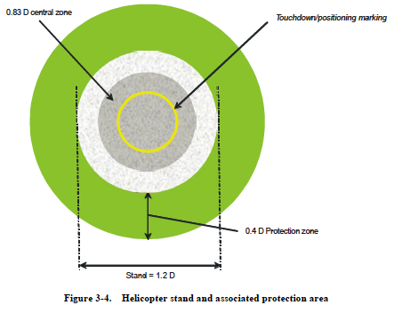
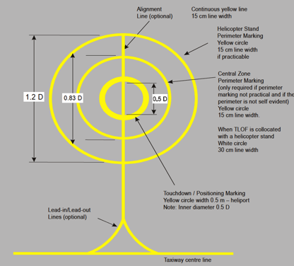


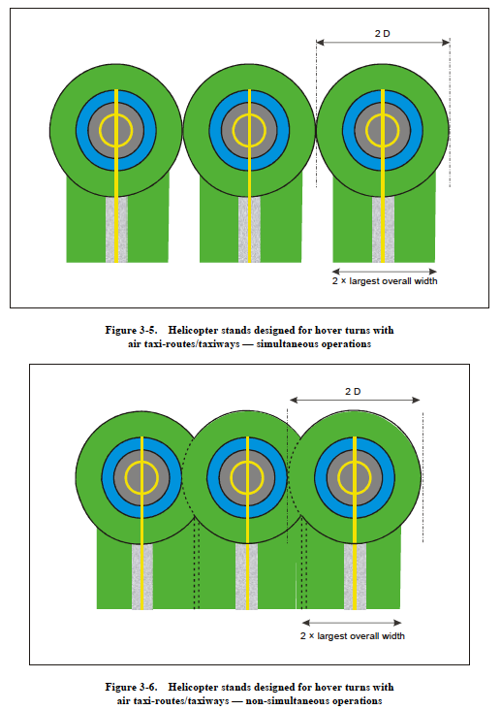

FINAL APPROACH & TAKEOFF-AREA (FATO)
Item | Comment
Number of FATOs | 1
Obstacles within the FATO (FATO must be obstacle free): | YES, ITS OBSTACLE FREE
 | YES
  DIMENSIONS OF THE FATO:
  - Class I Operations – Must be at least one 1D:
  - Class II Operations (over 3175kg MTOW) - Must be at least one 1D
  - Class III Operations (under 3175kg MTOW) – Must be at least one.83D
Slope of FATO:  - Not more than 5° for Class I Operations  - Note more than 7° for Class II & III Operations | NOT MORE THAN 5 DEGREES
FATO Surface Resistant to the effects of rotor wash: Yes or no | YES
FATO Surface Capable of providing ground effect: Yes or No | YES
FATO Surface Bearing Strength  - Performance Class I – Sufficient to support rejected take-off  - Performance Class II & III – Sufficient for static load bearing | YES
Are the FATO/s located near Taxiway Intersections, Runways or High Powered Run-up Areas where Airplane Vortex or Jet Blast is a problem: Yes or No | NO

SAFETY AREAS & ProtectEd Slide Slope around FATO
Item | Comment
Is there a Safety Area around the each FATO: Yes or no | YES
Slope of the Safety Area?  (May not exceed 4° outward from FATO) | COMPLIANT
Is the Safety Area FOD free: Yes or No

Obstacles within the Safety Area. List type and number. | Only Frangible objects that are required and must not exceed a height 25cm from the edge of the FATO and not penetrate plane sloping 5° upward and outward from the edge of the FATO.  FATO of 1D – maximum height of object is 5cm (recommended only)  NIL
Size of Safety Area – Class I Operations | ABOVE 3M
Size of Safety Areas – Class II & III Operations | Safety Surrounding a FATO must extend outward from the FATO to a distance of 3m or .5D which ever is larger.  Quadrilateral FATO – Safety Area sides must be at least 2D in length. –  Circular FATO – Safety Area Outer Diameter must be at least 2D  Comment: COMPLAINT
Protected Slide Slope around Safety Area: (Size and Slope Angle) Yes or No | (45° slope rising from the edge of the Safety Area to a distance of 10m)  Comment:  COMPLIANT
Obstacle Penetrating the Protected Side  (List type & Number) | NIL
This is for S-76 helicopter or smaller only. Larger helicopters will require large space. | State Dimensions of SAFETY AREA & PROTECTED SLIDE SLOPE  TLOF 13.28m x 13.28m  FATO: 16m x 16m  Safety Area 32m x 32m  Protected Side Slope:  10m from the edge of the safety area  Sloped at 45°  Concrete Pad

HELICOPTER REJECTED TAKEOFF AREA & CLEARWAY
Item | Comment
Rejected Take-off Area provided: Yes or No  - Required for CLASS I Operations  - Recommended for Class II & III Operations | COMPLIANT
Helicopter Clearway Provided: Yes or No  - Required for Class I Operations.  - Recommended for Class II & III Operations | NO
Location of Rejected Take-off Area:  - Starting at the edge of the FATO extended beyond to conform to the RFM data | YES
Load Bearing ability of Rejected Take-off Area:  - 1.66 time the MTOW  - See Construction data | UNDETERMINED
Location & Dimensions of the Clearway:  - Located beyond the Rejected Take-off Area  - Same width as Safety Area | UNDETERMINED
List type & number of obstacles within the Clearway  - No obstacle or surface may penetrate a plane sloping 3° up and outward from the edge of the FATO  - Must be free of obstacles that present danger to the helicopter.  Remove if possible | TREES AND FENCE
Load Bearing ability of Clearway  - 1.5 time the MTOW  - Reference test data | UNDETERMINED

HELIPORT IDENTIFICATION MARKINGS
Item | Comment
FATO TYPE  - RUNWAY TYPE FATO – Yes or No (AGIP Base Only)  - HOSPITAL FATO --------- Yes or No (None for AGIP)  - OTHER TYPE FATO –--- Yes or No (Swamp Locations & Brass) | SINGLE PAD FATO
Is the Landing “H” Properly displayed: Yes or No  - Within the FATO ------------------------------------------ Yes or No  - Center of TLOF ------------------------------------------- Yes or No  - White Color ------------------------------------------------ Yes or No  - Proper Dimensions( 3m x 1.8m x 0.4m) ----------- Yes or No  - In the preferred direction of take-off & landing --- Yes or No | YES
 | YES
  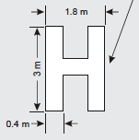
FATO Perimeter Line  - State shape of FATO: Rectangular, Square or Circle  - White dashed line 1.5 meters long, 30cm wide: Yes or No  - Spacing between dashes is 1.5 - 2.0 meters: Yes or No | COMPLIANT
TLOF Perimeter Line  - .3 meter wide continuous white line: Yes or No  - Located on the edge of the TLOF located in FATO: Yes or No | COMPLIANT
AIMING POINT - NA  - ONLY NECESSARY AT AGIP BASE  - Located on the FATO: Yes or No  - 9 meter equilateral triangle: Yes or No  - 1meter wide white line: Yes or No  - Aligned in the approach & take-off direction; Yes or No | NOT APPLICABLE
Heliport Name Markings  - Visible from all angles  - White letters not less than 1.5 meters in height | COMPLIANT

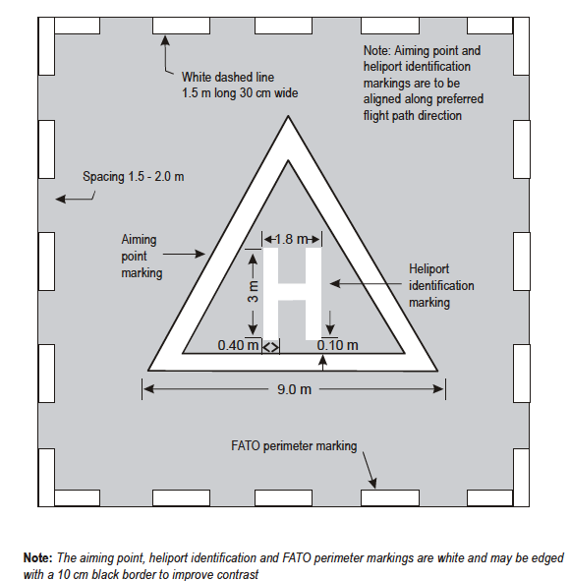

HELICOPTER ALIGNMENT GUIDANCE SYSTEMS
Flight Path Alignment Guidance Marking
- Installed : Yes or No
- Location : FATO or TLOF or Safety Area
- Arrow in the direction of Approach and/or departure : Yes or No
- Arrow is 50cm in width & 3 meters in length: Yes or No
- Arrow color - white on green back ground: Yes or No
Ref : Annex 14 Vol. II Page 5-19, 5-20
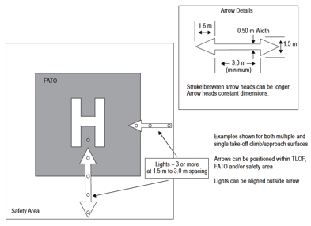  Ref : Annex 14 Vol. II, Fig. 5-9, Page 5-20 | 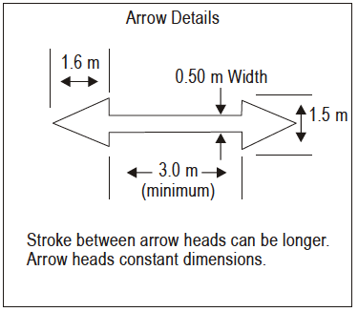
Flight Path alignment Guidance Marking Lights  - Omnidirectionnel steady white lights : Yes or No  - Row of three or more lights of 6m minimum length : Yes or No  - Alighned within the Arrow of the Flight Path Alignment Guidance Marking : Yes or No  - Uniformly spaced 1.5m – 3m between lights :Yes or No  - Serviceable : Yes or No  - Emergency Power Supply : Yes or No | NOT APPLICABLE
Visual Alignment Guidance System  INSTALLED (Should be installed if no approach lighting is installed, visual clues are difficult, obstacle clearance requires certain approach direction):  LOCATION:  CHARACTERICTICS  - Located on the downwind edge of FATO:  - In the preferred approach direction:  - Guides aircraft to FATO:  - Clears all obstacles on the approach:  - Frangible and mounted low:  - Azimuth is adjustable to +/- 5°:  - Guidance shall include three sectors: Offset left, offset right  Serviceable:  Emergency Power Connection: | NOT APPLICABLE
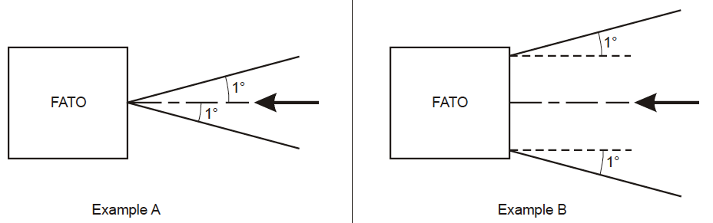
Visual Approach Slope Indicator System  INSTALLED (Should be installed if the helicopter requires a stabilized approach or visual clues are difficult or obstacle clearance requires a particular slope to be flown):  CHARACTERICTICS  Located on the downwind edge of FATO:  In the preferred approach direction:  Guides aircraft to FATO:  Clears all obstacles on the approach:  Frangible and mounted low:  Azimuth is adjustable to 1°-12° above horizon:  Serviceable:  Emergency Power Connection: | NOT APPLICABLE
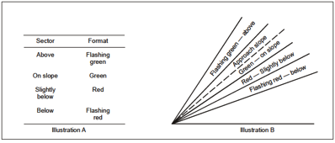
HAPI SIGNAL FORMAT Fig 5-15
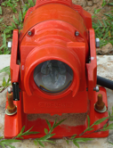 | NOT APPLICABLE
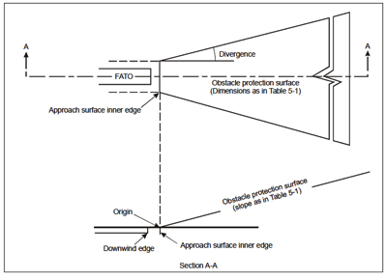  Fig 5-14  Obstacle protection surface for visual approach slope indicator systems | Dimension and Slope of the Obstacle Protection Surface  Table 5-1  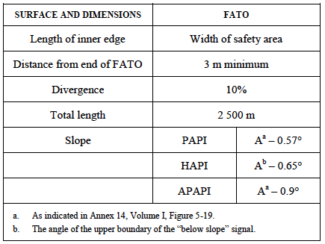

HELIPORT Lighting
Item | Comment
TLOF Lighting  - Intended for night use: Yes or No  (Must be provided if heliport is used at night)  - Perimeter Lights: Yes or No  - Floodlights: Yes or No  (Must have either perimeter lights or floodlights)  Perimeter Lights  - Aligned along edge of the TLOF (within 1.5 meters of boundary)  - Spacing between lights not more than 5 meters  - Minimum of 4 lights per side, Light in each corner  - Omnidirectional green colour lights  - No higher than 25cm above surface  - Serviceable: Yes or No  - Emergency Power Supply: Yes or No  Floodlights  - Minimum of four  - Place to avoid glare to pilots  - Serviceable: Yes or No  - Emergency Power Supply: Yes or No  Annex 14 Vol. II, | YES  YES  YES  YES  YES  YES  UNKNOWN  YES  YES  2 UNSERVICEABLE
Touchdown Position Marking Circle Lights  - May use floodlights  - Yellow coloured lights: Yes or No  - Lights installed on TDPM Circle Line: Yes or No  - No higher than 2.5cm above surface: _______________  - Must be able to with stand helicopter weight: Yes or No  - Serviceable: Yes or No  - Serviceable: Yes or No  - Emergency Power Supply: Yes or No  Annex 14 Vol. II | FLOOD LIGHTS
 | COMPLIANT
  FATO Lighting
  (Maybe omitted if TLOF lighting is coincidental with FATO Lighting)
  - Shape of FATO:
  Square or Rectangular:
  - Lights placed along edge of FATO: Yes or No
  - Minimum of four light per side: Yes or No
  - No more than 50 meter spacing between lights: __________
  - Light placed in each corner: Yes or No
  - 25cm or less above surface: Yes or No
  - Fixed omnidirectional white lights: Yes or No
  - Serviceable: Yes or No
  - Emergency Power Supply: Yes or No
  Circular – NA
  Annex 14 Vol. II
Heliport Beacon  - Installed: Yes or No  - Location: __________________________________  - Elevated: Yes or No  - Emits repeated series of equi-spaced short duration white flashes; Yes or No  - Visible from all angles  - Serviceable: Yes or No  - Emergency Power Supply: Yes or No  Annex 14 Vol. II | NOT INSTALLED
Approach Lighting  INSTALLED (In the preferred direction of approach): Yes or No  LOCATION (along a straight line in a preferred direction of approach):  CHARACTERICTICS  A Center Row of Three Lights spaced at 30m apart: Yes or No  Cross Bar of lights at 90m from FATO edge, bisecting the center row of lights at  90°, spaced at 4.5m: Yes or No  Lights: Steady Flashing  Omnidirectional: Yes or No  Color: White Other color ________________  Lights beyond the Cross Bar: Yes or No  - Lights: Steady Flashing  - Omnidirectional: Yes or No  - 30m spacing: Yes or No  - Aligned with center row lights, bisected by Cross Bar at 90°:  Visible at all angles and azimuth: Yes or No  Does lighting cause dazzle to pilots (requires a night flight to test):  Adjustable intensity: Yes or No  - Can be switched on & off at pilot request: Yes or No  Emergency Power Supply: Yes or No  Serviceable: Yes or No  Annex 14 Vol. II | NOT INSTALLED
Status Lights  The purpose of this system is to provide a high-intensity ‘international red’warning signal (flashing red light) to flight crews when conditions on the Installation are unsafe for the helicopter and/or occupants. Any installation onshore or offshore that has hydrocarbon emissions must be equipped with status lights.  - Required: Yes or No  - Installed: Yes or No  - Flashing Red light: Yes or No  - Automatic Switching: Yes or No  - Dual Filliment: Yes or No  - Emergency Power Supply: Yes or No  Guidelines for the Management of Aviation Operations | NOT INSTALLED

Helicopter Type | D Value | Main Rotor Diameter | 0.05D | 0.12D | 0.21D | Distance of “H” from deck edge (0.4D) | Aiming circle inside diameter (0.5D) | 0.62D | 0.83D | “t” value | Landing net size
Bell 206 - L4 | 12.9 | 11.6 | .65 | 1.5 | 2.7 | 5.2 | 6.45 | .8 | 10.7 | 2.3 | Not Required
Bell 407 | 12.6 | 10 | .63 | 1.5 | 2.6 | 5.0 | 6.3 | 7.8 | 10.5 | 2.7 | Not Required
Bolkow 105D | 12 | 9.9 | 0.6 | 1.44 | 2.52 | 4.8 | 6 | 7.44 | 9.96 | 2.4 | Not required
EC135 | 12.19 | 10.2 | 0.61 | 1.46 | 2.51 | 4.8 | 6.1 | 7.55 | 10.12 | 2.9 | Not required
Bolkow 117 | 13 | 11.0 | 0.65 | 1.56 | 2.73 | 5.2 | 6.5 | 8.45 | 11.05 | 3.2 | Not required
Agusta 109 | 13.05 | 11.0 | 0.65 | 1.57 | 2.74 | 5.22 | 6.53 | 8.1 | 10.83 | 2.6 | Small
SA365 | 13.68 | 11.93 | 0.68 | 1.64 | 2.87 | 5.47 | 6.84 | 8.48 | 11.35 | 4.3 | Not required
EC155 | 14.3 | 12.6 | 0.72 | 1.72 | 3.00 | 5.72 | 7.15 | 8.87 | 11.87 | 4.8 | Small/medium
S76 | 16.00 | 13.40 | 0.80 | 1.92 | 3.36 | 6.40 | 8.00 | 9.92 | 13.28 | 5.3 | Medium
Agusta Westland AW139 | 16.66 | 13.8 | 0.83 | 2.0 | 3.50 | 6.66 | 8.33 | 10.3 | 13.82 | 6.4 | Medium
Agusta Westland AW189 | 18.0 | 14.60 | 0.90 | 2.16 | 3.78 | 7.2 | 9.0 | 11.16 | 14.94 | 8.6 | Super Medium
Bell 412 | 17.13 | 14.00 | 0.86 | 2.06 | 3.6 | 6.85 | 8.57 | 10.62 | 14.22 | 5.2 | Not required
Bell 212 | 17.46 | 14.63 | 0.87 | 2.10 | 3.67 | 6.98 | 8.73 | 10.83 | 14.49 | 5.1 | Not required
AS332L | 18.7 | 15.00 | 0.94 | 2.24 | 3.93 | 7.48 | 9.35 | 11.60 | 15.52 | 8.6 | Medium
AS332L2 | 19.5 | 16.20 | 0.98 | 2.34 | 4.1 | 7.8 | 9.75 | 12.09 | 16.19 | 9.3 | Medium
Bell 214ST | 18.95 | 15.85 | 0.95 | 2.27 | 3.98 | 7.58 | 9.48 | 11.75 | 15.73 | 8 | Medium
EC225 | 19.5 | 16.20 | 0.98 | 2.34 | 4.1 | 7.8 | 9.75 | 12.09 | 16.19 | 11.0 | Medium
S92A | 20.88 | 17.17 | 1.04 | 2.51 | 4.38 | 8.35 | 10.44 | 12.95 | 17.33 | 12.6t | Large
S61N | 22.2 | 18.90 | 1.11 | 2.66 | 4.66 | 8.88 | 11.10 | 13.76 | 18.42 | 9.3 | Large
EH101 | 22.8 | 18.60 | 1.14 | 2.74 | 4.79 | 9.12 | 11.40 | 14.14 | 18.92 | 14.3 | Large

The above highlighted aircraft are authorized to land on: ……………..

HELICOPTER TAXI WAYS & TAXI ROUTES (NOT APPLICABLE TO SWAMP LOCATIONS)
Helicopter GROUND Taxiways & GROUND Taxi Routes
Note — A helicopter ground taxiway is intended to permit the surface movement of a wheeled helicopter under its own power.
- Installed : Yes or No
- Ground Taxiway Dimensions :
(1.5 x the width of the undercarriage)
(Centered on the taxi route centerline)
- Ground Taxi-Route Dimensions:
(Centered symmetrically on centreline out to .75 x overall helicopter width)
- Slope of Taxiway & Taxi Route :
(Longitudinal slope not to exceed 3°),
(Tranverse slope not to exceed 2°)
- Taxiway’s & Taxi Routes Maximum Static Load Bearing :
((at least 5.4 metric tons S-76 only)
- Resistant to rotor wash : Yes or No
- Rapid Drainage: Yes or No
Annex 14 Vol. II,

Helicopter AIR Taxiways & AIR Taxi Routes
Note.— A helicopter air taxiway is intended to permit the movement of a helicopter above the surface at a height normally associated with ground effect and at ground speed less than 37km/h (20 kt).
- Installed : Yes or No
- Air Taxiway Dimensions :
(2 x the width of the undercarriage)
(Centered on the taxi route centerline)
- Air Taxi-Route Dimensions:
(Centered symmetrically on centreline out to 1.0 x the overall helicopter width)
- Slope of Air Taxiway & Air Taxi Route :
(Shall not exceed the limits of the helicopter)
(Tranverse slope not to exceed 10°)
(Longitudinal Slope not to exceed 7°)
- Air Taxiway’s & Air Taxi Routes Maximum Static Load Bearing :
(at least 5.4 metric tons S-76 only)
- Resistant to rotor wash : Yes or No
- Rapid Drainage: Yes or No
- Provide Ground Effect: Yes or No
Annex 14 Vol. II

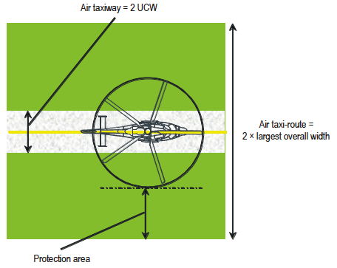

OBSTACLE LIMITATION REQUIREMENTS
Approach Surface. An inclined plane or a combination of planes or, when a turn is involved, a complex surface sloping upwards from the end of the safety area and centred on a line passing through the centre of the FATO.  Remarks. To the extent possible, obstacles penetrating the surface should be removed. For heliports used by performance class 2 and 3 helicopters, it is intended that approach paths be selected so as to permit safe forced landing or one-engine-inoperative landings such that, as a minimum requirement, injury to persons on the ground or water or damage to property are minimized.  Established: Yes or No  CHARACTERICTICS  - Width of FATO plus Safety Area:)  - Starts at the edge of the Safety Area:  - Centreline perpendicular to Safety Area edge:  - Will the path allow for a safe Forced or OEI Landing:  - Clears all obstacles on the approach:  - Obstacles underlying the Approach Surface:  - Penetrated by any obstacles:  - Outer edge rise to a height of 152 meters minimum:  - Straight or curved approach:  - Dimensions within with Annex 14 Table 4-1:  Annex 14, Vol. II | YES  YES  YES  NO  NO  NO  YES  STRAIGHT
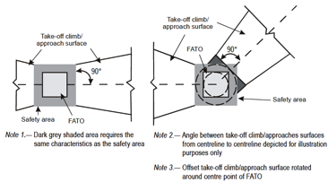
Obstacle limitation surfaces — Take-off climb and approach surface
Ref: Annex 14, Vol. II, Page 4-2
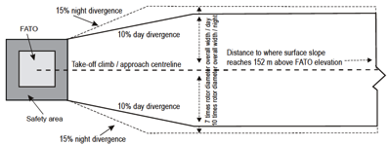
Take-off climb/Approach surface width
Annex 14, Vol. II
Take-off & Climb Surface (see above figures)  Description: An inclined plane, a combination of planes or, when a turn is involved, a complex surface sloping upwards from the end of the safety area and centred on a line passing through the centre of the FATO.  Remarks: For heliports used by performance class 2 and 3 helicopters, it is intended that departure paths be selected so as to permit safe forced landings or one-engine-inoperative landings such that, as a minimum requirement, injury to persons on the ground or water or damage to property are minimized.  Established: Yes or No  CHARACTERICTICS  Description: An inclined plane, a combination of planes or, when a turn is involved, a complex surface sloping upwards from the end of the safety area and centered on a line passing through the center of the FATO.  - Does the inter edge width equal the FATO plus Safety Area:  - Center Line perpendicular to inter edge & outer edge:  - Do the side edges began at the ends of the inter edge and diverge uniform land rise with respect to the vertical plane:  - Obstacles underlying the Take-off and Climb Surface:  - Clearway Provided: Yes or No  - If a Clearway is provided, the interedge of the Take-off & Climb surface shall start at outer edge of the Clearway: Yes or No or NA  - Dimensions within with Annex 14 Table 4-1:  Annex 14, Vol. II | YES, COMPLIANT
Remarks:

ADDITIONAL EQUIPMENT
Item | Comment
RUBBER OR SANDBAG CHOCKS: Yes or No  - Number:  =(must be rubber, wood or sandbags, minimum amount is one set for each wheel).  References for use of chocks below | NOT SIGHTED
Tie Down Straps  - Number:  - Breaking strength 12,000lbs: Yes or No  Guidelines for the Management of Aviation Operations, | NOT SIGHTED
Prohibitive Landing Marker: Yes or No  - 4 x 4 metre red flag with diagonal yellow cross  Guidelines for the Management of Aviation Operations, | NOT SIGHTED
Breathing Apparatus  - Number: 1  - Storage: CRASH BOX  - Serviceable: Yes or No YES  - Inspection Sticker Date: NOT SEEN  Minimum 2 sets with two reserve cylinders, stored in clearly marked and secure watertight cabinets or chests, container should be painted green and market with white letters, located close to the helideck and one on the fire truck, conduct operational check, make fireman put on the apparatus and breath it.  Guidelines for the Management of Aviation Operations, | COMPLIANT
Windsock:  - Number: 1  - Position for best effect: YES  - Colour & condition: ORANGE, GOOD CONDITION  - Illuminated: Yes or No  (Must be lit for night operations)  Annex 14, Vol. II, | COMPLIANT
Helicopter starter unit: Yes or No  - Number:  - Type:  - Condition: (Rectifier or battery trolley, 28 VDC)  - serviceability: Yes or No  Guidelines for the Management of Aviation Operations, | NO

TURBULENCE
Item | Comment
Items like to cause turbulence  - Number of structures:  - Type structure  - Emissions: Hot or Cold  Items likely to cause turbulence, i.e. towers, powerlines, derricks, cranes, flares, hot emission, cold emissions and other etc.  Guidelines for the Management of Aviation Operations, | NIL

Fire Fighting Equipment
 | Comment
The level of protection to be provided for rescue and fire fighting is be based on the overall length of the longest helicopter normally using the heliport. The principle fire fighting agent is FOAM.
Category of helicopter: H1, H2 or H3  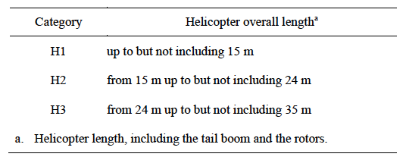 | Minimum Amounts of Extinguishing Agent Required 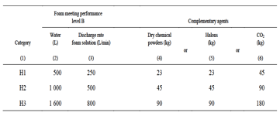
FOAM  - Quantity on site  - Level B Performance: Yes or No  - Type: (1%-6%)  - Backup quantity on site: (100%)  Ref: Annex 14, Vol. II | FOAM
Foam Monitors:  - Number of Monitors:  - Type:  (Aspirated, Non-aspirated, Manual, Oscillating)  Ref: AGIP Aviation Manual, Page 467, 1171, 1172, 1199, 1200 | H2
Foam System Maintenance & Testing Schedule  - FOAM Test Certificate Date:  - Water Test: Yes or No  - FOAM Monitor Test: | 120LITRES  YES  3% AFF COMPLIANT
Complementary Fighting Agent on Site:  - Two fire extinguishers of dry powder: Yes or No  - Two fire extinguishers of CO2: Yes or No  - Total Quantity of Dry Chemical:  - Total Quantity of Halon:  - Total Quantity of CO2:  Annex 14, Vol. II | COMPLIANT
Water available on site:  - Quantity of water available  - Number of Hydrant Points:  - Location of Hydrant Points:  - Main water pressure always on for helicopter landings: Yes or No  Annex 14, Vol. II | NONE
Discharge Rates of Fire Fighting Agents  - FOAM Discharge rate:  - Dry powder discharge rate:  - Halon discharge rate:  - CO2 discharge rate:  Annex 14, Vol. II | Required Discharge Rates for Fire Fighting Agents 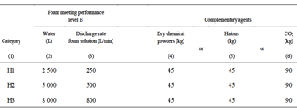
FOAM Hand Branch Pipes  - Number:  - Condition:  - On/Off Control: | NIL
Crash Box  - Crash Box Provided: Yes or No  - Crash Box accessible and water proof: Yes or No  - Location of Crash Box:  - Contains all equipment required: Yes or No  - List Missing Equipment:  - Condition of Equipment:  Annex 14, Vol. II | COMPLIANT
Required Equipment Contained in each Crash Box  - Adjustable wrench  - Rescue Axe, non-wedge or aircraft type  - Bolt Cutters (60mm)  - Crowbar (105cm)  - Hook, grab or salving  - Heavy duty hacksaw with 6 spare blade  - Fire Resent Blanket  - Ladder (length appropriate to helicopter in use  (H3 Helicopter category only)  - Lifeline (5cm diameter / 15 meter length)  - Side Cutting Pliers  - Set of assorted screwdrivers  - Harness cutting knife with sheath  - Fire Resistant Gloves (2 pair for H2 & 3 pair  for H3 category helicopters)  - Power Cutting Tool  Ref: Guidelines for the Management of Aviation  Operations | COMPLIANT

Protective Clothing for Fire Fighters & Helideck crews
Item | Comment
Quantity, quality and condition of protective clothing: (available for each member of helideck crew)  - Two piece suits (bunker coat and trousers) to meet standard EN469 or equivalent, OR  - One piece suits (preferably orange) to meet standard EN 469 or equivalent – Yes or No  - Helmet with full face visor to meet BS 3864 or equivalent – Yes or No  - Gloves to meet standard EN 659 or equivalent – Yes or No  - Boots to meet standard EN 345 or equivalent – Yes or No  Ref: Guidelines for the Management of Aviation Operations, | COMPLIANT
Stowage for fire fighting equipment:  - Stored properly: Yes or No | YES
HLO & HDA identifying waistcoat & equipment:  - Are ID Vests/ Coat, glasses, boots, gloves and helmet worn by deck crews: Yes or No  - Do the waist coats/vest clearly ID HLO & HDAs with the letters HLO or HDA: Yes or No  - Reflective material on front and back of waistcoat: Yes or No  - Flame retardant material: Yes or No  Ref: Guidelines for the Management of Aviation  Operations, | YES  YES  YES

Water rescue
Item | Comment
Note: Where a facility intends to use the surface of water for a FORCED LANDING AREA, or water underlies the Approach Obstacle Surface or the Take-off & Climb Obstacle Surface, then water rescue must be available. | UNKNOWN
Water Rescue Boats  - Available during all aviation operations: Yes or No  - Location:  - Type boats: | UNKNOWN
Personnel Manning Rescue Boats  - Number:  - Trained Personnel: Yes or No | UNKNOWN
Procedures  - Are procedures in place for helicopter operations: Yes or No  - SOP Published: Yes or No | UNKNOWN

ACCESS to Helideck / helipad
Item | Comment
How is access to the Helideck/Helipad controlled?  - Security Measures in place: Yes or No  - HLO / HDA escort: Yes or No  - Locked Gates: Yes or No  - Perimeter Fence: Yes or No  - Posted as a restricted area: Yes or No  - Armed Guards: Yes or No | COMPLIANT
Safety Notices:  - Available and clearly readable: Yes or No | COMPLIANT

Radio Operator & Radio Equipment
Item | Comment
Is the Radio Operator  - Radio & Operator posted: Yes or No  - Competent: Yes or No  - Licensed: Yes or No  - Knowledge of and access to SOPs and Emergency Procedures: Yes or No  Ref: Guidelines for the Management of Aviation  Operations, Page: | NO LICENCE
Do daily reports & departure messages contain all necessary information?  - Position: Yes or No  - Weather: Yes or No  - Fuel state: Yes or No or NA  - Personnel awaiting transport: Yes or No  Ref: Guidelines for the Management of Aviation  Operations, | COMPLIANT
Portable multi-channel hand held Radio (air band) including head set  - Number of Radios:  - Number of Headsets:  - Radio Chargers available: Yes or No  - Condition of Radios  - Condition of Headsets:  - Spare Radio & Headsets: Yes No  Ref: Guidelines for the Management of Aviation  Operations, | COMPLIANT
Airband radios  - Type Air Band Radio Base Unit:  - Condition:  - Is a backup available & serviceable: Yes or No  Ref: Guidelines for the Management of Aviation  Operations, | COMPLIANT
Portable VHF FM: (if applicable): Yes or No | COMPLIANT
NDB  - Type:  - Installed: Yes or No  - Frequency:  - Identifier:  - Multi-Frequency Re-tuneable: Yes or No  Ref: Guidelines for the Management of Aviation Operations, | NOT APPLICABLE
Radio Log – Record of helicopter movements, POB, endurance, etc.  - Helicopter Take-off & Departure Time & Date Recorded: Yes or No  - Endurance recorded: Yes or No  - POD recorded: Yes or No  Ref: Guidelines for the Management of Aviation Operations | COMPLIANT

Meteorological Reports & Equipment
Item | Comment
Are weather reports in standard ICAO format: Yes or No  Ref: Guidelines for the Management of Aviation Operations | NON-COMPLIANT
Anemometer (fixed)  - Installed: Yes or No  - Calibration date: (Annual)  - Serviceable: Yes or No  Ref: Guidelines for the Management of Aviation Operations | NON-COMPLIANT
Anemometer (hand) – calibration date (annual).  - Available: Yes or No  - Calibration date: (Annual)  - Serviceable: Yes or No  Ref: Guidelines for the Management of Aviation Operations, | NON-COMPLIANT
Wind direction:  - Installed: Yes or No  - Location (Must be positioned in clear air):  - Calibration date: (Annual)  - Serviceable: Yes or No  Ref: Guidelines for the Management of Aviation Operations, | NON-COMPLIANT
Air temperature –  - Installed: Yes or No  - Location:  - Calibration date:  Ref: Guidelines for the Management of Aviation Operations, | NON-COMPLIANT
Precision barometer/Twin Altimeters  - Installed: Yes or No  - Location:  - Calibration date: (Annual)  - Serviceable:  Ref: Guidelines for the Management of Aviation Operations, | NON-COMPLIANT
Visibility and cloud base equipment  - Installed: Yes or No  - Calibration date: (Annual)  - Serviceable; Yes or No  Ref: Guidelines for the Management of Aviation Operations, | NON-COMPLIANT
Maintenance Schedule for instruments (especially automated systems):  - Daily/Weekly Checks by Observer Recorded: Yes or No  - Automated System installed: Yes or No  - Scheduled maintenance & calibration in accordance with manufactures instructions: Yes or No (written record or certificate)  Ref: Guidelines for the Management of Aviation Operations | NON-COMPLIANT

Miscellaneous
Item | Comment
Are pre-landing checks in accordance with a checklist & SOPs?  Ref: Guidelines for the Management of Aviation Operations | COMPLIANT
Dangerous Goods  - Reference material on site: Yes or No  - Number of Qualified Personnel:  - Packaging Material Available: Yes or No  - Certificate to Transport DG by Air: Yes or No  Ref: ICAO Doc 9284 AN/ 905Technical Instruction for the Safe Transport of Dangerous Goods by Air  Ref: Guidelines for the Management of Aviation Operations, | NON-COMPLIANT
Helideck Manning Level – normally minimum of HLO plus three HDAs and two firemen.  - Number HLOs (one minimum):  - Number of HDAs (three minimum):  - Number of Firemen (two minimum):  Ref: Guidelines for the Management of Aviation Operations, | 1 HLO  1 HAD  1 FIREMAN
Helicopter emergency diagrams & safety posters  - Location:  - Types:  Ref: Guidelines for the Management of Aviation Operations | COMPLIANT
Helideck training exercises –  - Written record (to be carried out at least once every month): Yes or No  - Training Schedule: Yes or No  Ref: Guidelines for the Management of Aviation Operations | COMPLIANT
Video/CD player for showing passenger safety briefings  - Suitable supervised area for briefing room: Yes or No  - Video/CD Player: Yes or No  - Briefing CD for helicopter type: Yes or No  Ref: Guidelines for the Management of Aviation Operations | COMPLIANT
Heavy-duty scales for baggage and freight: calibration date (annual).  Ref: Guidelines for the Management of Aviation Operations | COMPLIANT
Stretcher – type and location.  Ref: AGIP Aviation Manual, Page: 106, 295, 370, 380, 1161  Ref: Guidelines for the Management of Aviation  Operations | COMPLIANT

Aviation Fuel System
Item | Comment
Type of System  - Make:  - Condition:  - Pump running light:  - Quick release connector on bonding lead: | NOT APPLICABLE
Date of last Inspection  - Authorised Fuel Inspector:  - Date:  - Date: | NOT APPLICABLE
On-Site Procedures  - Weekly & Daily checks  - Provision of Shell test kits | NOT APPLICABLE
Documentation  - Retention of paperwork | NOT APPLICABLE

HELIDECK CREW
Item | Comment
HLO (Training to OPITO or equivalent standard)  - HLO Course  Validity 2 years  - Heli Team Members  - Radio Licence  UKOOA Management of Offshore Helidecks  UK CAA CAP 437 | EXPIRED
HDA (Training to OPITO or equivalent standard)  - Heli Team member  Validity 3 years  - DG by Air Awareness  UKOOA Management of Offshore Helidecks | EXPIRED
Heli Admin  - Radio Licence  - DG by Air Awareness  UKOOA Management of Offshore Helidecks  UK CAA CAP 437 | NO RADIO LICENCE
Manning Policy  - Current industry practice suggested the helideck crew consists of an HLO + 3.  UKOOA Management of Offshore Helidecks  UK CAA CAP 437 | 1HLO + 1HDA + 1FIREMAN
Documentation and continuation training.  - Exercises and drills.  UKOOA Management of Offshore Helidecks  UK CAA CAP 437 | COMPLIANT

dangerous goods
Item | Comment
Qualified personnel  UKOOA Management of Offshore Helidecks | COMPLIANT
Packaging  UKOOA Management of Offshore Helidecks | UNKNOWN

LANDING SITE INSEPCTION REPORT
Executive Summary / Non-Conformances / HLL

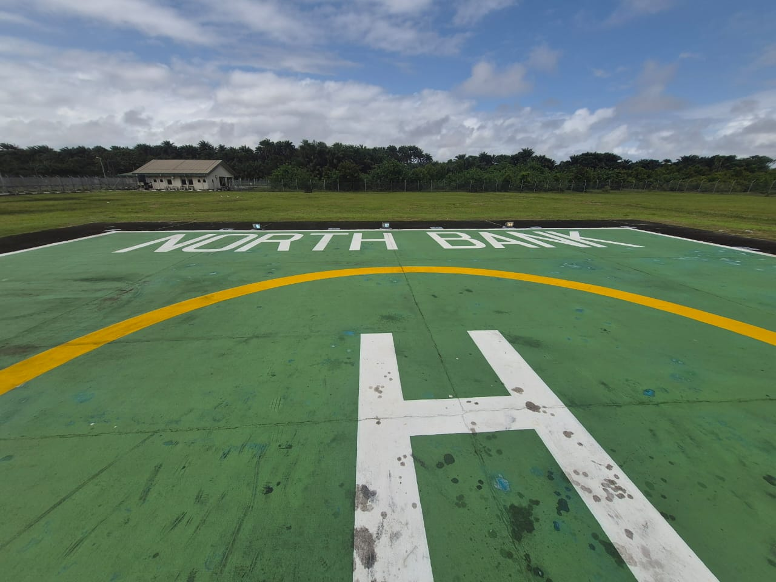

Installation/Vessel Name | NORTH BANK
Owner/Operator | RENAISSANCE
Inspector | OLISA KENECHUKWU
Operational Clearance  (Day/Night) | DAY ONLY
D Value & T Value | 21M, 12.6T
Date of Previous Inspection | 27TH SEPT 2024
Date of Current Inspection | 1ST SEPT 2026
Date of Next Inspection  (Maximum 2 years – Manned locations)  (Maximum 3 years – NUI locations) | 31ST AUG 2028
NCAA certificate validity

INSPECTION REPORT INFORMATION

The Inspection Report should be completed by a trained helideck inspector and is the formal documentation of the landing site inspection. The inspection report should be completed as soon as possible but within two weeks recommended time frame of the actual inspection and submitted to the Base Managing Pilot / Chief Pilot. The inspector should discuss the non-conformities with the Base Chief Pilot and any recommended limitations that he feels are needed.
The Base Managing Pilot / Chief Pilot should consult with the training department and complete the HLL listing with limitation if there are any. If no limitations are imposed on the landing site the HLL listing should be annotated ‘No limitations imposed on this landing site’.
The HLL must be updated to include all restrictions imposed on the landing site. The operation’s room landing site white board should be updated with current information followed by the Landing Site Status Report updated at the end of the month.
The Base Managing Pilot / Chief Pilot should then endorse the HLL listing and publish on the company’s HUMP and distribute by email to all company chief pilots for their awareness of the inspection and limitations
This Inspection Report is designed to be used by the helideck inspector to record his results after conducting an inspection. The completed inspection checklist will be placed on the company’s HUMP. The most current copy of the Inspector’s Executive Summary, Non Conformity Listing and HLL Listing will also be kept in hard copy in a designated folder marked ‘Landing Site HLL Listing’ in the flight planning room
Non-conformances are classified as:
- High Priority Critical Actions (these actions must be addressed before air operations can commence)
- Medium Priority Actions (these actions may impact continued operations and restrictions may be imposed)
- Low Priority Actions (these actions may lead to operating restrictions and must be addressed before a full approval is given)
This helideck inspection report in conjunction with the operation’s landing site status report and any relevant risk assessments form the documentation necessary to show that the landing sites being operated to, are safe for purpose. A progressive inspection program of landing sites maybe be put into place between full inspections to ensure the continued suitability of the landing area for air operations. If so done such progressive reports should be annotated with the word ‘Revision’ and date of such revision should be indicated.

Inspector’s Executive Summary

Inspectors Executive Summary: I carried out a Heliport Inspection of the NORTH BANK on the 1ST of September 2026. This inspection was conducted in accordance with the UK CAA CAP 437 and all other supporting documents. The Facility manager and HLO, were very instrumental during the inspection exercise and efforts are well appreciated.
The Helideck team showed a good level of competence in carrying out their duties. They don’t have an operational digitalized weather report system in place. They report weather by visual observation. I recommend that all the flood lights be one colour or type of illumination and in general be brighter.
The Perimeter lights did not work, the facility manager said it was an electrical issue with the switch, that will be rectified immediately.
The HLO’s certificate was expired so recertification will be required, radio operator certificates were not sighted, I recommend that a weather reporting system be installed. Lastly their DGR manual was not sighted request for the manual has been made. Overall, it was a successful inspection, and the crew seemed to be willing to make these corrective adjustments.

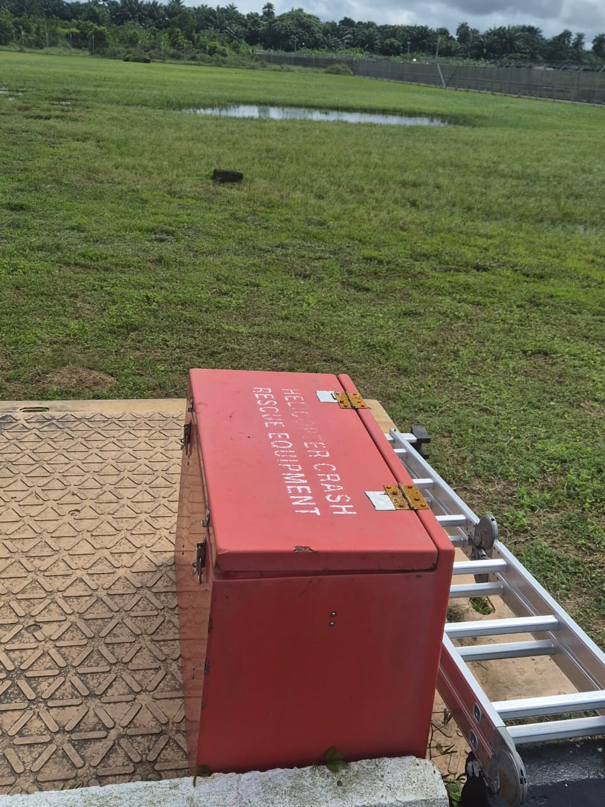CRASH BOX | 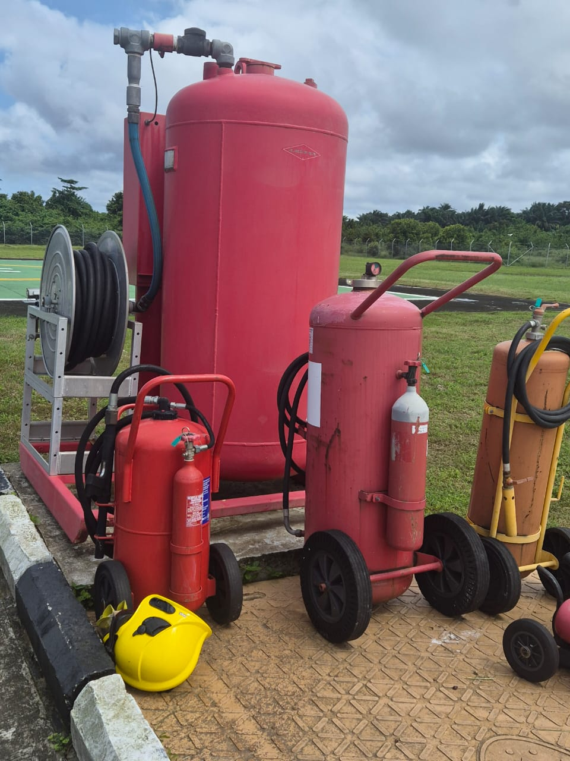FIRE FIGHTING SYSTEM
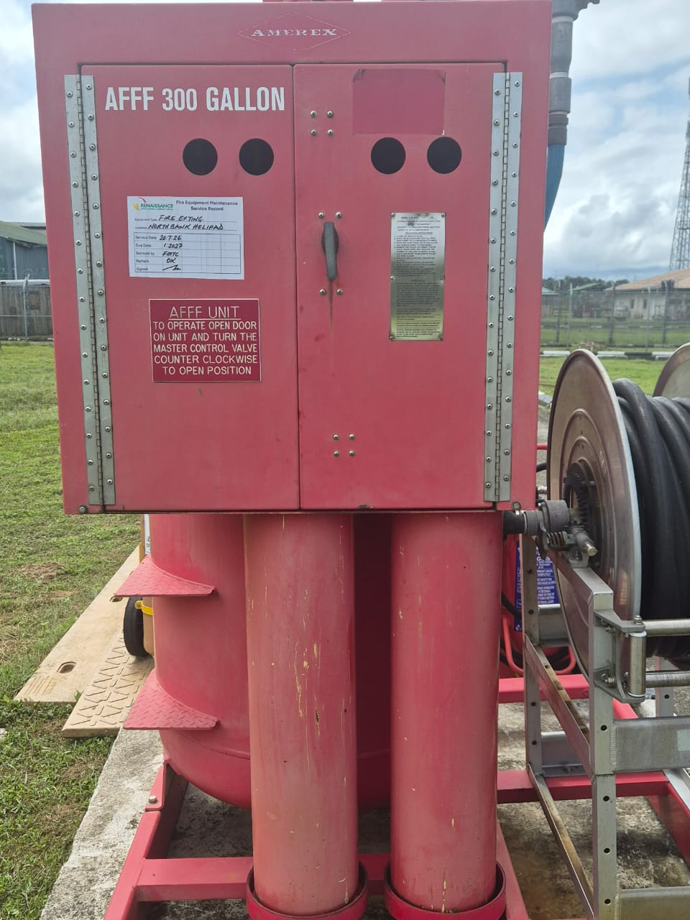AFF SYSTEM | 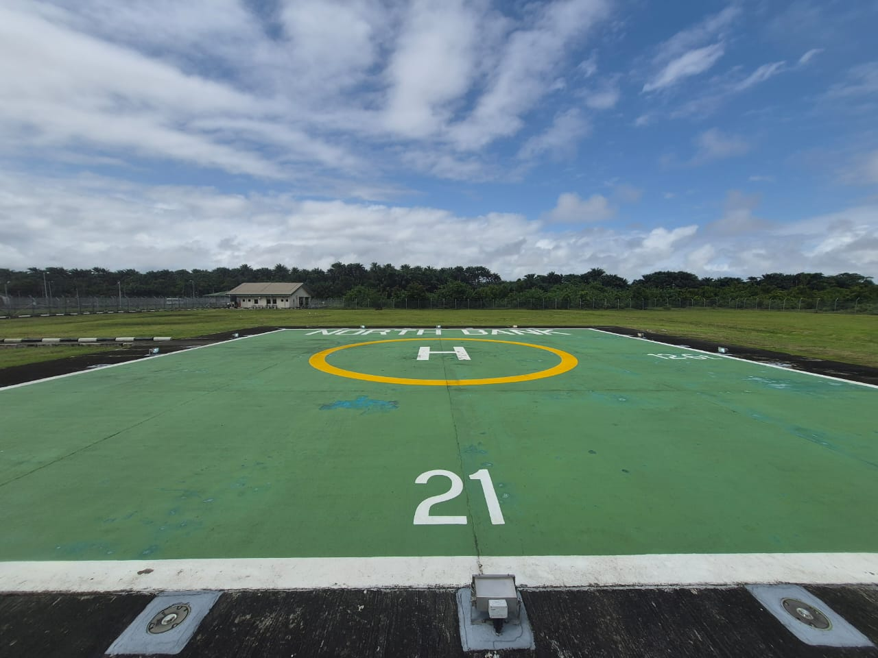
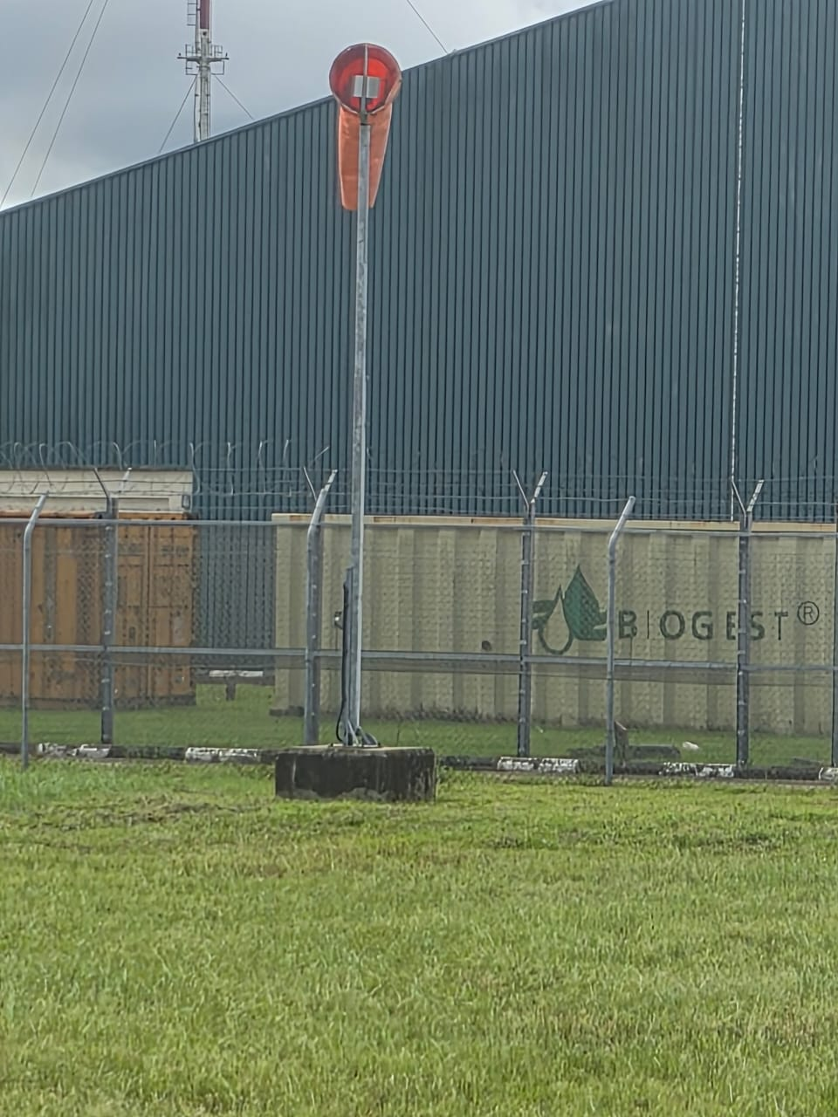 | 
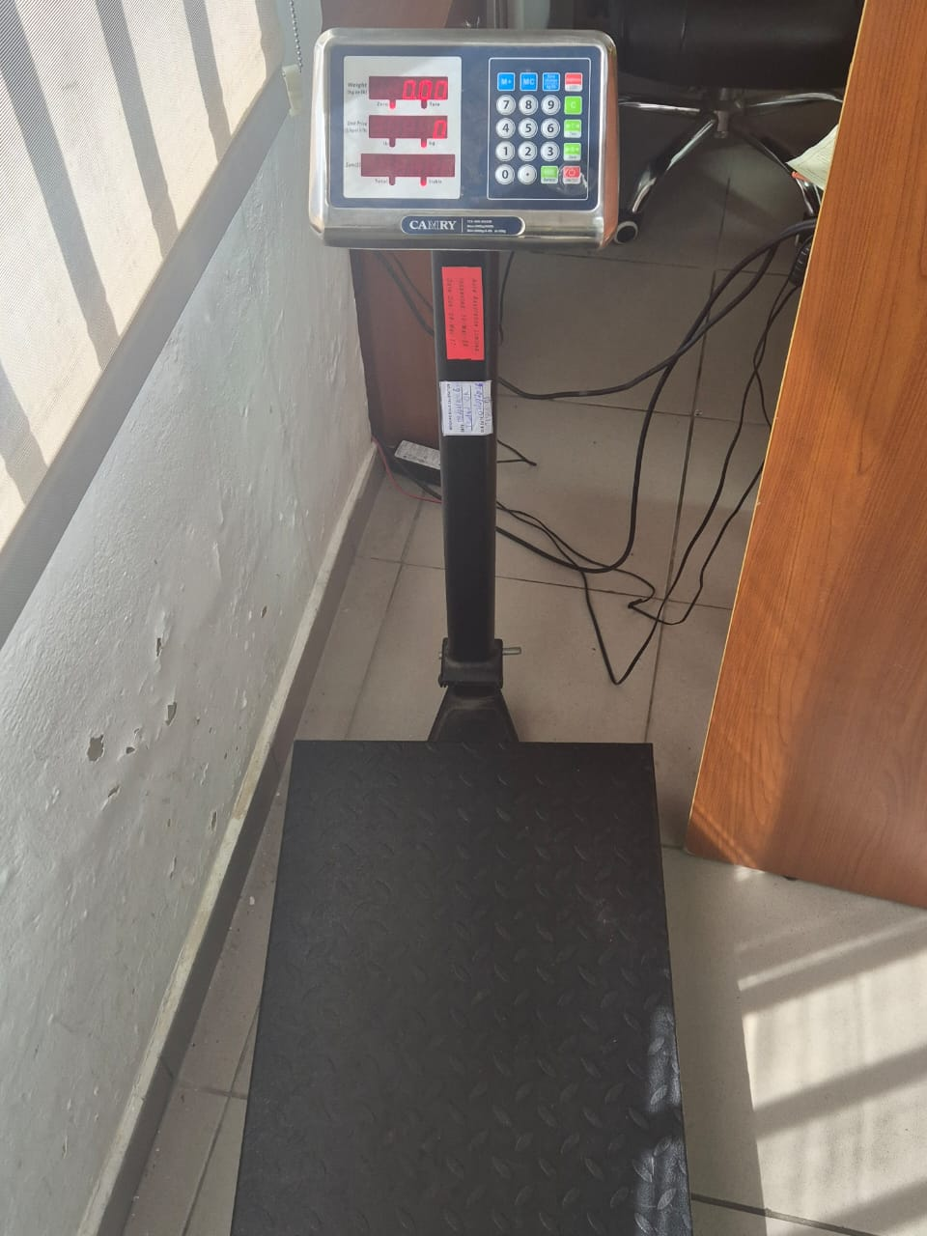 | 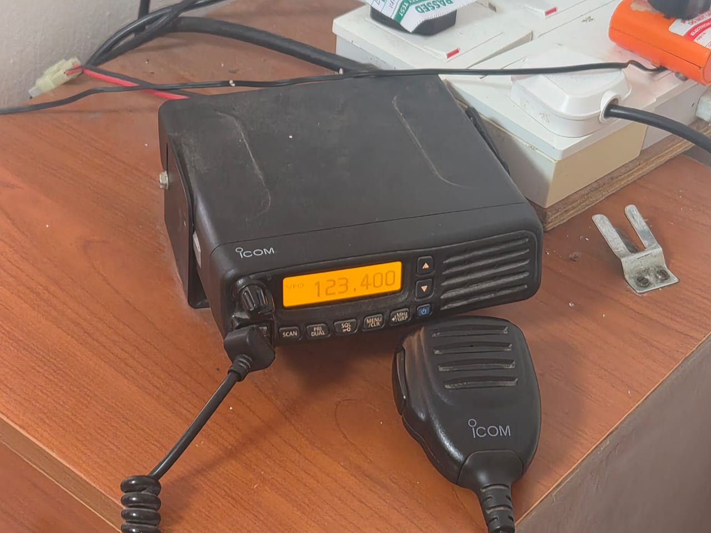
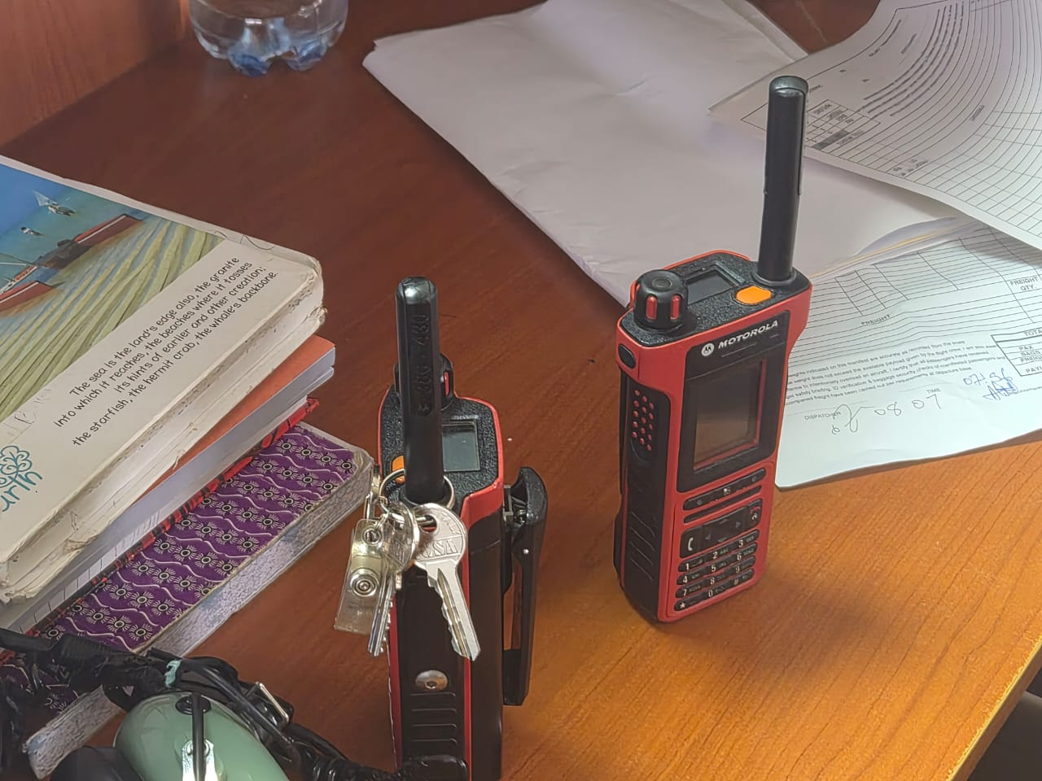 | 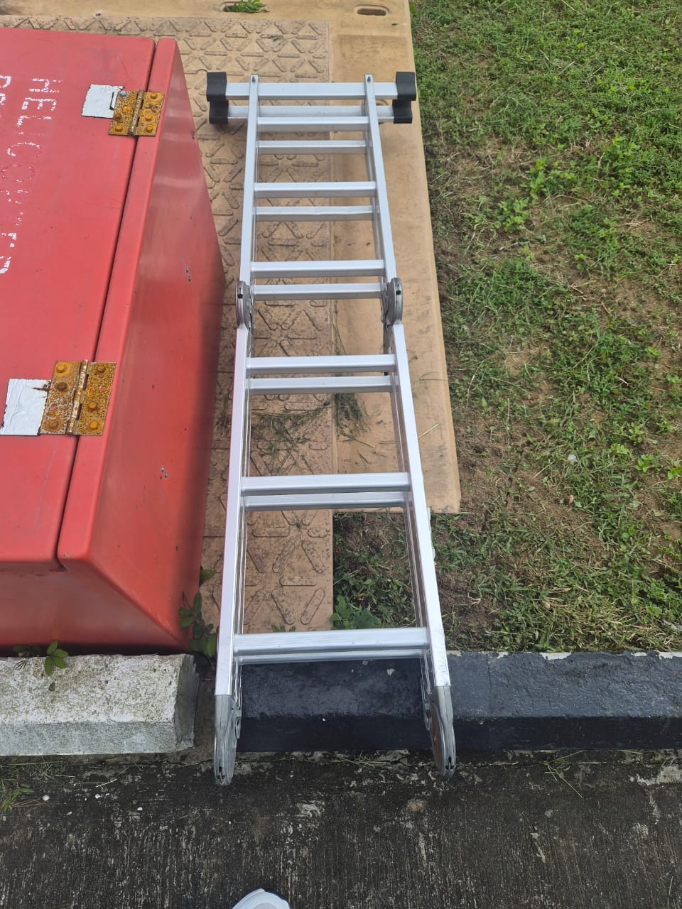

Non-conformances are classified as:
- High Priority Critical Actions: (these actions must be addressed before air operations can commence)
- Medium Priority Actions: (these actions may impact continued operations and restrictions may be imposed)
- Low Priority Actions: (these actions may lead to operating restrictions and must be addressed before a full approval is given)
FORMAL LIST OF NON-COMPLIANCE
# | Non Compliance | Action Party | Priority  (High/Med/Low) | Target Closure Date  (Specify specific date) | Date  Closed | How was Closure Verified
1 | HLO LICENCE EXPIRED | RENAISSANCE | MED | 30TH SEPT 2026
2 | NO WEATHER REPORTING DEVICE | RENAISSANCE | MED | 30TH SEPT 2026
3 | PERIMETER LIGHTS DON’T COME ON | RENAISSANCE | MED | 30TH SEPT 2026

Recommendations to improve the helideck procedures, equipment or best practice. Not mandatory

Recommendations
 | Recommendation | Action party | Priority |  | Date closed | Comments
1 | 2 FLOOD LIGHTS DON’T WORK REQUIRE REPLACEMENT | RENAISSANCE | LOW
2 | REPLACEMENT OF THE FLOOD LIGHTS TO A BRIGHTER FLOOD LIGHTS | RENAISSANCE | LOW
HELIDECK LIMITATIONS LIST (HLL)
Aircraft Type | Limitation Imposed | Reason for Limitation | Date Limitation Effective | Date Limitation Removed | Reason Limitation Removed

LANDING SITE INSPECTION ENDORSEMENT

Location Name
Date of inspection

Heliport Inspector | Name: OLISA KENECHUKWU  Signature:  Date: 16TH SEPT 2026
Base Managing Pilot / Chief Pilot | Name:  Signature:  Date:
Head Of Flight Operations | Name:  Signature:  Date:
Quality and safety Manager | Name:  Signature:  Date:
Helideck Inspection Report entered on to HUMP | Date:

This landing site inspection report is based on the inspection conducted by a trained and approved company landing site inspector. The base Managing Pilot / Chief Pilot confirms that it has reviewed the inspection report in conjunction with the inspection checklist and with the inspector and associated non-conformances. Appropriate restrictions to operations have been reviewed with the training department and limitations or restrictions to operations have been documented on the HLL.
Local base Managing pilot / Chief Pilot confirms that this document will be available to flight crews and that this report has also been placed on the HUMP and distributed by email as indicated below.
Email Distribution List
- All BHNL Managing pilots / Chief Pilots
- Head of Flight Operations
- Quality & Safety Operations Lagos
- Designated Client Liaison officer
- Client
- Vessel Owner / Operator

The contents of this report should be provided to the owner / operator of the landing site and a suitable program agreed to address the non-conformities.

